WEEK 1- Insurance Database

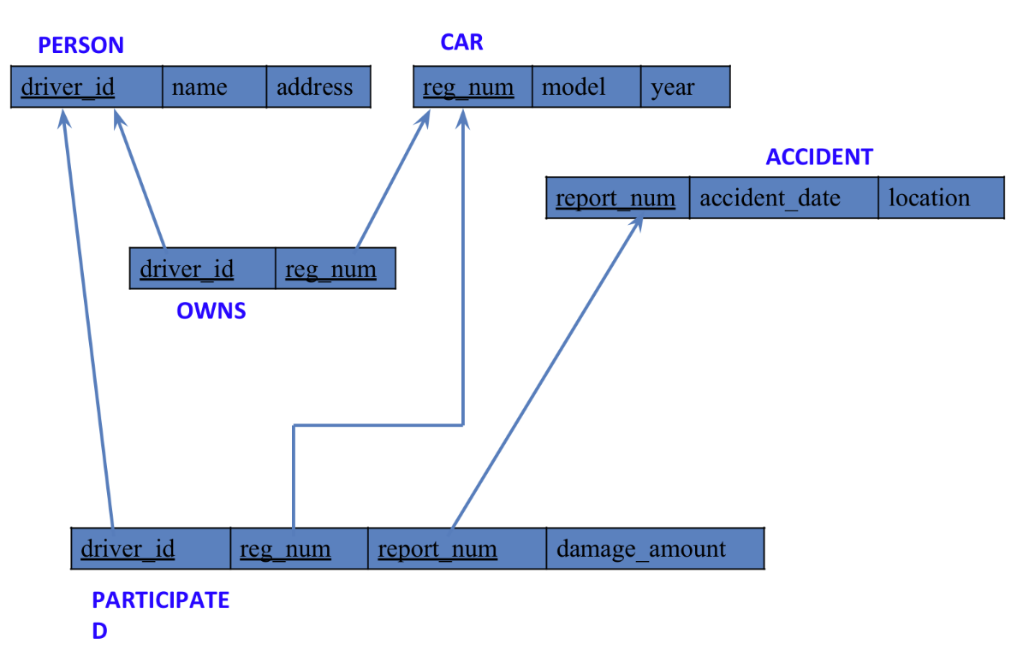

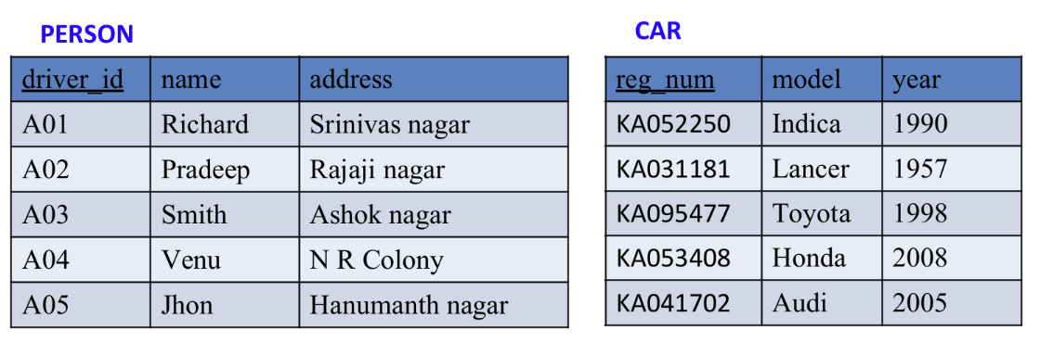

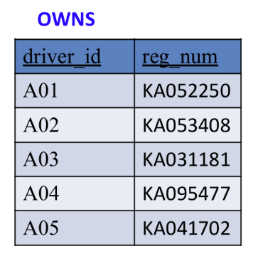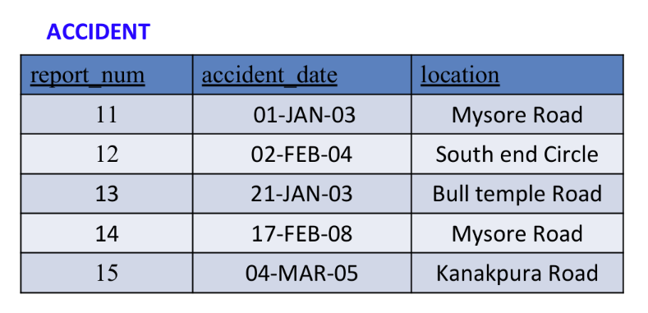

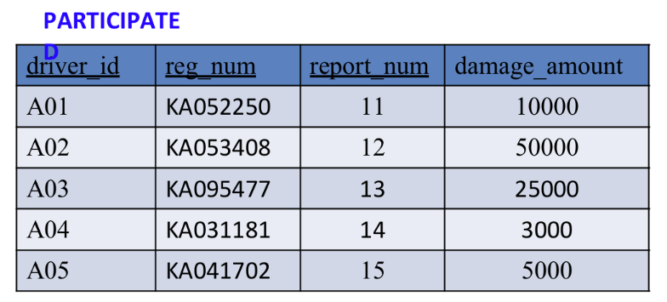

**Create the above tables by properly specifying the primary keys and the foreign keys. (CREATION)**

create database insurance_dhiksha;

use insurance_dhiksha;

create table insurance_dhiksha.person(

driver_id varchar(20),

name varchar(30),

address varchar(50),

PRIMARY KEY(driver_id)

);

create table insurance_dhiksha.car(

reg_num varchar(15),

model varchar(10),

year int,

PRIMARY KEY(reg_num)

);

create table insurance_dhiksha.owns(

driver_id varchar(20),

reg_num varchar(10),

PRIMARY KEY(driver_id, reg_num),

FOREIGN KEY(driver_id) REFERENCES person(driver_id),

FOREIGN KEY(reg_num) REFERENCES car(reg_num)

);

create table insurance_dhiksha.accident(

report_num int,

accident_date date,

location varchar(50),

PRIMARY KEY(report_num)

);

create table insurance_dhiksha.participated(

driver_id varchar(20),

reg_num varchar(10),

report_num int,

damage_amount int,

PRIMARY KEY(driver_id,reg_num,report_num),

FOREIGN KEY(driver_id) REFERENCES person(driver_id),

FOREIGN KEY(reg_num) REFERENCES car(reg_num),

FOREIGN KEY(report_num) REFERENCES accident(report_num)

);

**Enter at least five tuples for each relation (INSERTION)**

insert into person values("A01","Richard", "Srinivas nagar");

insert into person values("A02","Pradeep", "Rajaji nagar");

insert into person values("A03","Smith", "Ashok nagar");

insert into person values("A04","Venu", "N R Colony");

insert into person values("A05","John", "Hanumanth nagar");

insert into car values("KA052250","Indica", "1990");

insert into car values("KA031181","Lancer", "1957");

insert into car values("KA095477","Toyota", "1998");

insert into car values("KA053408","Honda", "2008");

insert into car values("KA041702","Audi", "2005");

insert into owns values("A01","KA052250");

insert into owns values("A02","KA031181");

insert into owns values("A03","KA095477");

insert into owns values("A04","KA053408");

insert into owns values("A05","KA041702");

insert into accident values(11,'2003-01-01',"Mysore Road");

insert into accident values(12,'2004-02-02',"South end Circle");

insert into accident values(13,'2003-01-21',"Bull temple Road");

insert into accident values(14,'2008-02-17',"Mysore Road");

insert into accident values(15,'2004-03-05',"Kanakpura Road");

insert into participated values("A01","KA052250",11,10000);

insert into participated values("A02","KA053408",12,50000);

insert into participated values("A03","KA095477",13,25000);

insert into participated values("A04","KA031181",14,3000);

insert into participated values("A05","KA041702",15,5000);

**Select from table (SELECTION)**

select * from person;

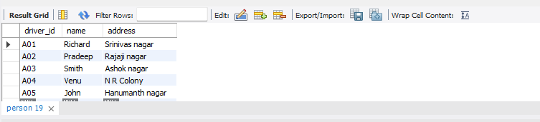

select * from car;

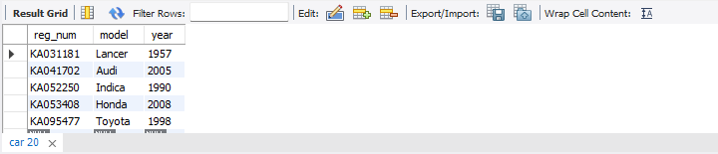

select * from owns;

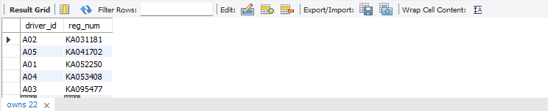

select * from accident;

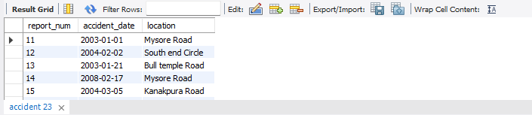

select * from participated;

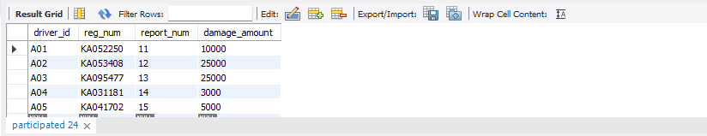

**QUERIES:**

* **Update the damage amount to 25000 for the car with a specific reg-num (example 'KA053408' ) for which the accident report number was 12.**

update participated

set damage_amount=25000

where reg_num='KA053408' and report_num=12;

* **Find the total number of people who owned cars that were involved in accidents in 2008.**

select count(distinct driver_id) CNT

from participated a, accident b

where a.report_num=b.report_num and b.accident_date like '2008%';

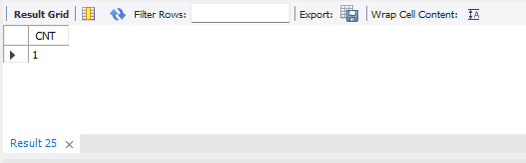

* **Add a new accident to the database.**

insert into accident values(16,'2008-03-08',"Domlur");

select * from accident;

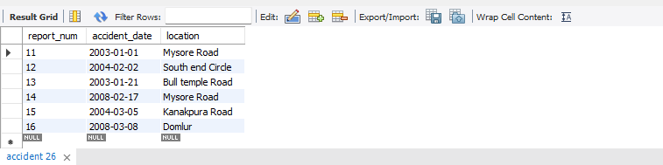

**TO DO:**

* **Display Accident date and location**

select accident_date, location from accident;

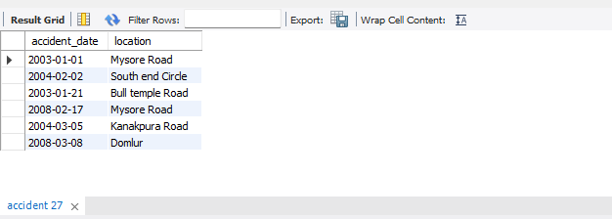

* **Display driver id who did accident with damage amount greater than or equal to Rs.25000**

select driver_id from participated where damage_amount>=25000;

